[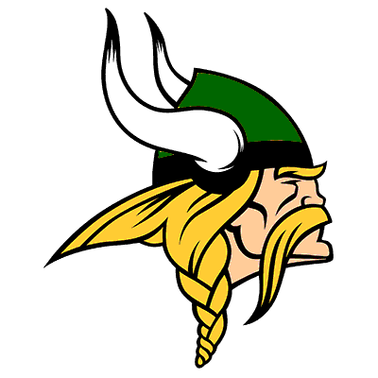](https://www.google.com/url?sa=i&rct=j&q=&esrc=s&source=images&cd=&cad=rja&uact=8&ved=2ahUKEwiB6bWTpMjhAhUFcq0KHZzpCNwQjRx6BAgBEAU&url=https://www.maxpreps.com/high-schools/northland-vikings-(columbus,oh)/home.htm&psig=AOvVaw31x7aOuZSge2IM4v5BJSw5&ust=1555080414374584)

NORTHLAND HIGH SCHOOL

2024 VIKINGS JV FOOTBALL

SCHEDULE

GAME DATE OPPONENT TIME RESULTS

1 August 24th @ Central Crossing HS 10:00am _______

2 August 31st @ Whitehall HS 10:00am _______

3 September 9th @ OPEN TBD _______

4 September 16th @ Granville HS 5:00pm _______

5 September 23rd @ Eastmoor HS 5:30pm _______

6 September 28th @ Bishop Ready HS 10:00am _______

7 October 7th @ Centennial HS 5:30pm _______

6 October 14th @ St. Francis DeSales HS 5:30pm _______

7 October 19th @ St. Charles HS 10:00am _______

**2024 Vikings Coaching Staff:**

**Head Coach:** Chris Tucker

**Assistant Coach**: Jalen Wells

**Principal:** Jason Johnson

**Athletic Director:** Mario Bowles

**Athletic Trainer:** Kasey Wentzel